University of Waterloo
Faculty of Engineering
Department of Electrical and Computer Engineering

NE 217
Laboratory 5

Prepared by
Surname, Legal Given Name(s)
UW Student ID Number: 2NNNNNNN
UW User ID: uwuserid @uwaterloo.ca

Prepared by
Surname, Legal Given Name(s)
UW Student ID Number: 2NNNNNNN
UW User ID: uwuserid @uwaterloo.ca
2B Electrical/Nanotechnolgy Engineering
21 June 2017
5.1 Stating the Problem
Summarize in a sentence or two the problem of approximating the solution to Laplace’s equation
in two and three dimension together with Dirichlet and insulated boundary conditions.
Your summary here.

5.2 Determining the Formal Parameters
We are approximating a solution to Laplace’s equation in two and three dimensions. There is only one required parameter:
- The 2D or 3D array U.
Describe the properties of this array in Table 5.2.
Table 5.2 Inputs to the functions laplace2d and laplace3d.
Given Values | Description
U | Your description here ...

5.3 Determining the Return Values
The functions have a return value being a 2D or 3D array U_{out}. Describe this return values in Table 5.3 in your own words.
Table 5.3 Return value.
Symbol | Description
U_{out} | The matrix U_{out} is ...

5.4 The Signature and Description of the Matlab Function
Given the responses in 5.1, 5.2 and 5.3, fill in the description of the function here.
% REPLACE THIS TEMPLATE WITH YOUR COMMENTS AND SIGNATURE
% laplace2d
% Copy the description from 5.1 here
%
% Parameters
% ==========
% U
%
% Return Values
% =============
% U_out

function [U_out] = laplace2d( U )

5.5 Argument Checking
The next step is to check the argument. The argument must be either a 2D or a 3D array.
function [U_out] = laplace2d( U )
% Argument Checking

Copy your error checking here

function [U_out] = laplace3d( U )
% Argument Checking

Copy your error checking here

5.6 Describing the Solution
Three specific steps are described in the course slides. For each of the steps, provide an explanation in English. Your description need only be for laplace2d.
1. Errors and Warnings
Your description here.

2. Initialization
Your description here.

3. Mapping the unknown points to a unique number from 1 to m
Your description here.

4. Creating and solving a system of linear equations
Your description here.

5. Substituting the values back into the matrix U_{out}
Your description here.
Remember to describe your steps in English. This should not be Matlab-specific instructions, but rather a description of what needs to be done.
5.7 Implementing the Solution
The next step is to convert your code to Matlab code for laplace2d (you will have to write laplace3d on your own by modifying laplace2d; however, you will use it in the questions). Each of the steps you indicated in Question 5.6 will be translated into one or more Matlab commands. For each step, indicate the appropriate Matlab commands. If you define a local variable in any step, document the purpose of the variable.
% Error and Warning Checking
% ==========================
%
% Your description here.

Your commands here...

% Initialization
% ==============
%
% Your description here.

Your commands here...

% Mapping the unknown points to a unique number from 1 to m
% =========================================================
%
% Your description here.

Your commands here...

% Creating and solving a system of linear equations
% =================================================
%
% Your description here.

Your commands here...

% Substituting the values back into the matrix U_out
% ===================================================
%
% Your description here.

Your commands here...

You will be graded on coding style as well as functionality. Lack of proper indentation and comments will result in a loss of marks.
Once you have tested your function, copy the entire function here.

5.8 Testing your Implementation
We are now ready to test your code.
5.8a In the laboratory slides (pg 59), an example is shown where the boundary conditions are given by the values shown in Figure 1.
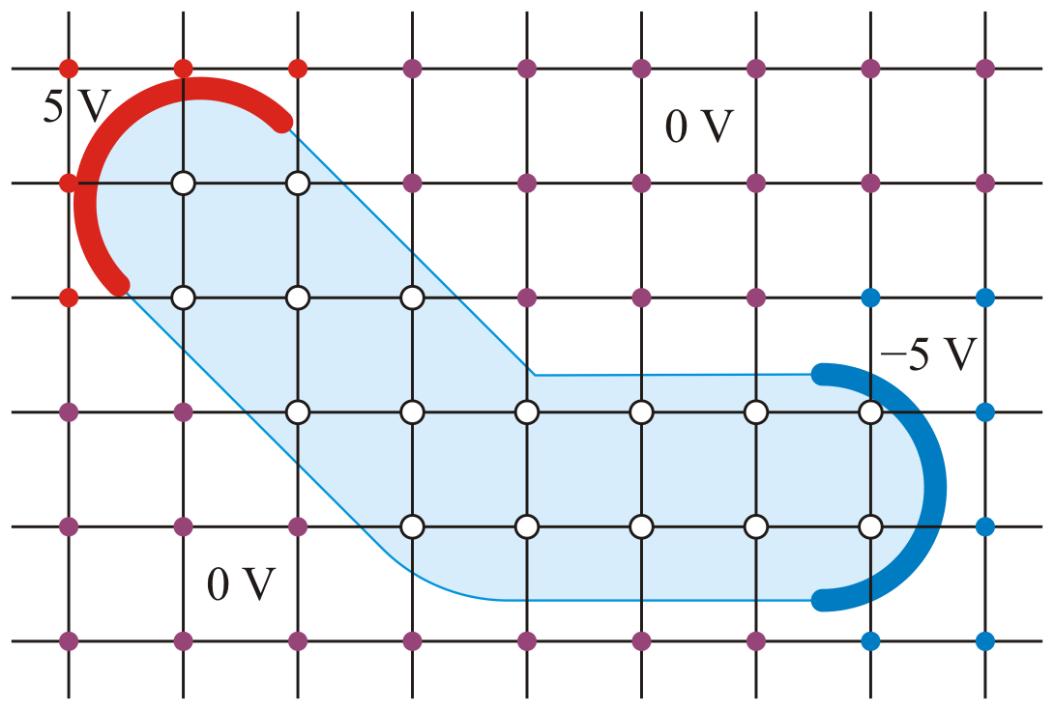
Figure 1. The first approximation.
For simplicity, this array may be defined as:
U5a = zeros( 6, 9 );
U5a(1:3,1:3) = 5;
U5a(3:6,8:9) = -5;
U5a(2:3,2:3) = -Inf;
U5a(3:4,3:4) = -Inf;
U5a(4:5,4:8) = -Inf;
Find the output matrix U_{5a,out} and copy it here.
Copy and paste your Matlab commands and the output here.

5.8b Repeat Question 5.8a with insulated boundaries:
U5b = NaN*ones( 6, 9 );
U5b(1:3,1:3) = 5;
U5b(3:6,8:9) = -5;
U5b(2:3,2:3) = -Inf;
U5b(3:4,3:4) = -Inf;
U5b(4:5,4:8) = -Inf;
Find the output matrix U_{5b,out} and copy it here.
Copy and paste your Matlab commands and the output here.

5.8c Suppose you are in a room where one wall is 100 ºC, the two walls adjacent to this hot wall are 0 ºC and the fourth wall opposite the hot wall and the ceiling and floor are insulated. Because the ceiling and the floors are insulated, symmetry allows you to ignore this dimension and proceed in two dimensions. Solve Laplace’s equation in this room using an 81 × 81 grid. Use the mesh command (mesh( U )) to plot the temperature throughout the room and copy that plot into Figure 2 with your UW User IDs as the titles. Determine the temperature in the middle of the insulated wall.

Figure 2. A supporting plot.

The temperature close to the middle of the insulated wall is: .

5.8d Consider a situation where you have a situation as shown in Figure 3: this is a cross section of a rectangular cable with one surface at 100 V, the opposite surface at 0 V and the two sides are insulated. In the interior of the cable are two wires: one at 20 V and the other at 40 V.
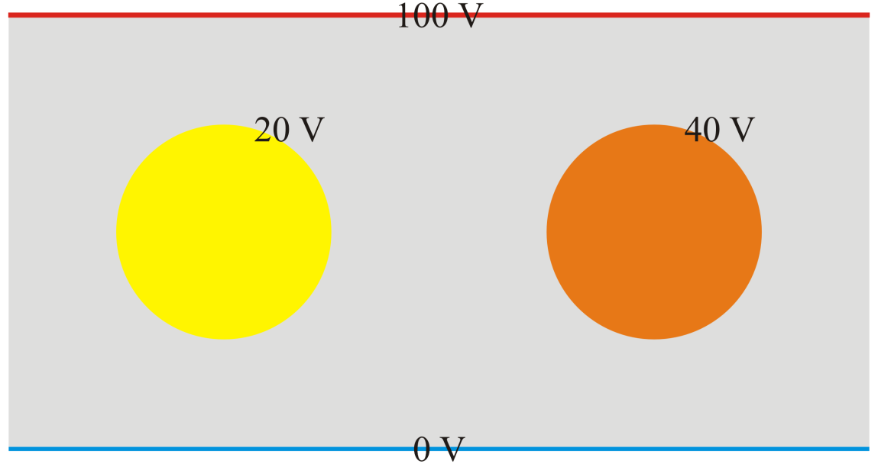
Figure 3. A cross section of a rectangular cable.
Approximate the cross section using a 21 × 41 grid of points. Treat the wires as those points that are distance points or less from the points (11, 11) and (11, 31) in the grid, as is shown in Figure 4.
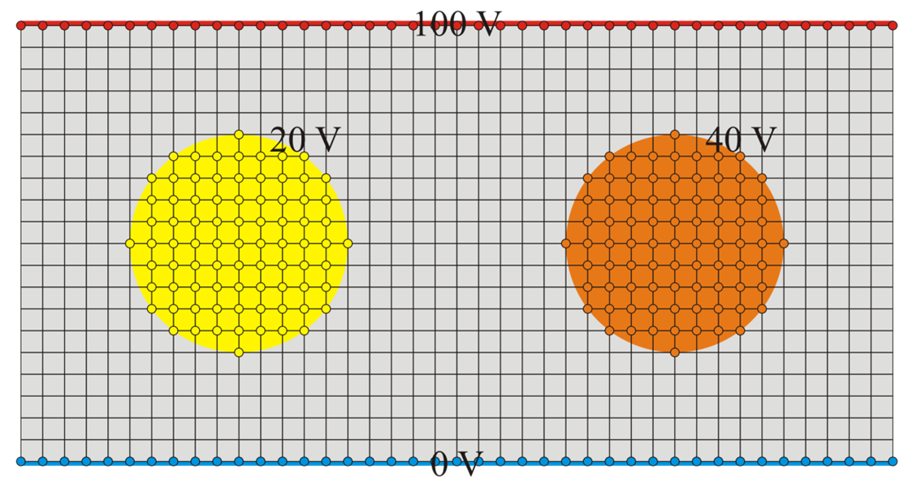
Figure 4. A 21 × 41grid superimposed on the points cable shown in Figure 3.

For example, consider the effect of
U5d( 11, 6:16) = 20;
U5d(8:14, 7:15) = 20;
U5d(7:15, 8:14) = 20;
U5d(6:16, 11) = 20;
Solve for the voltage potential at the interior points and plot the functions using the mesh command. Copy the plot from the mesh command to Figure 5.
Copy and paste the instructions to create and solve the matrix (without output) here.


Figure 5. A plot of an approximation of the voltage potentials of the cable in Figure 3.

5.8e In this question (courtesy of Prof. Sujeet Chaudhuri), you will simulate the voltage potential of a microstrip. Normally, the conducting strip is separated from the ground plane by a dielectric substrate and we will assume that the voltage potential in this substrate may be modeled by Laplace’s equation.
If the strip is too far from the ground plane, the voltage potential will flare out, as is shown in Figure 6.
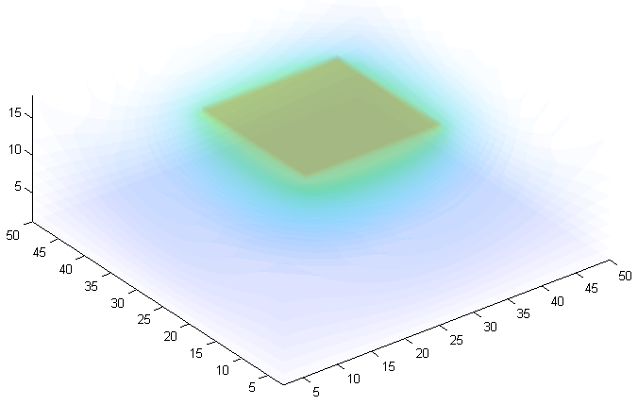Figure 6. A microstrip with a significant flare.
As the strip is moved toward the ground plane, the flaring is reduced as is shown in Figure 7.
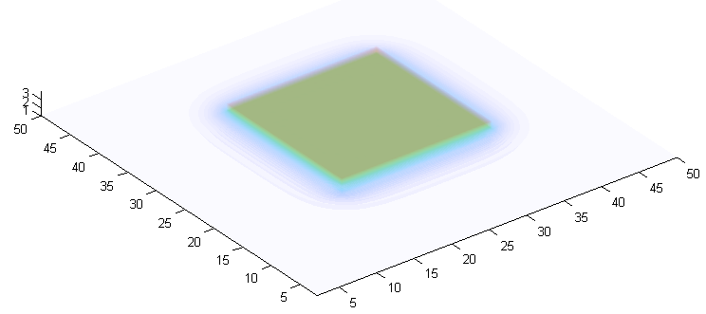Figure 7. A microstrip closer to the ground plane with a significantly reduced flare.
You will model this system as follows:
- The array will be 51 × 51 × n where 3 ≤ n ≤ 20.
- The lower surface (U(:, :, 1) = 0) will be ground plane at 0 V while all other surfaces will be insulated except for a 21 × 21 square in the centre of the surface oppose the ground plane. That square will be at 5 V.
- All other points are interior points that must be solved for.
Problem: Find the largest value of n such that there is no point in U(11,:,:), U(41,:,:), U(:,11,:) and U(:,41,:) that is greater than 1 V. Are there any symmetries you can use? Note that, for example, max( max( U(11, :, :) ) ) ignores entries in U that are NaN. You can look at Figure 8 for clarification.
Indicate your value of n here.
For that largest acceptable value of n, execute the Matlab commands (after uncommenting and modifying the appropriate title) and copy the plot into Figure 10.
isosurf( U_out, 51 );
% title( 'uwuserid' );
% title( 'uwuserid and uwuserid' );

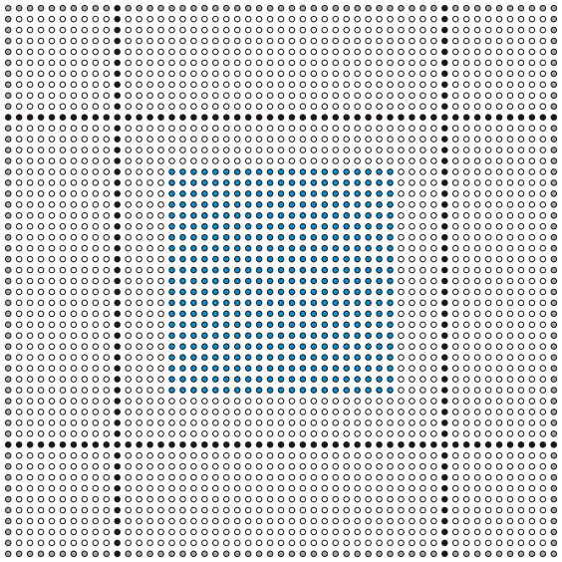
Figure 8. The grid of points.
For example, Figure 9 shows the boundary case when n = 20. In this example, you will see that the voltage is close to 1 V at the border. The flare is too great in this example. Replace Figure 10 with the output of the previous Matlab commands.
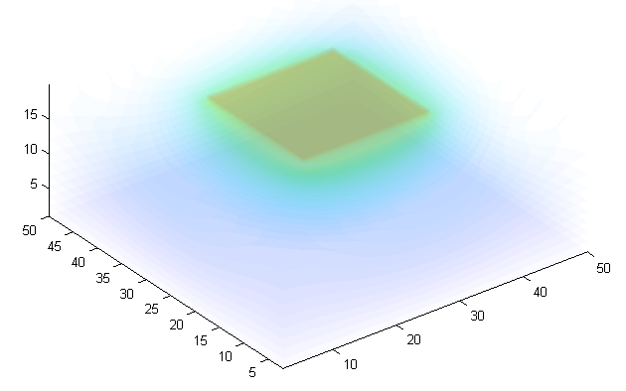Figure 9. The microstrip example when n = 20.


Figure 10. The microstrip example when n = ???.

5.9 Did you remember to copy your entire functions laplace2d into Question 5.7? That is, all comments and all code?

